Shear Stress-Shear Strain Error prediction

We begin by importing the libraries and reading the stress-strain dataset using regex.

The relationship of shear stress and shear strain follows the equation :

τc = τc0 +( τs - τc0 ) (1 - exp((1- θ0 \* γ)/τs)) + θ∞γ

where τc0 is critical resolved shear stress, τs is saturation stress, θ0 is initial hardening modulus, θ∞

is a remaining hardening modulus and γ is shear strain.

The curve obtained from plotting the the data points given in text file is as follows:

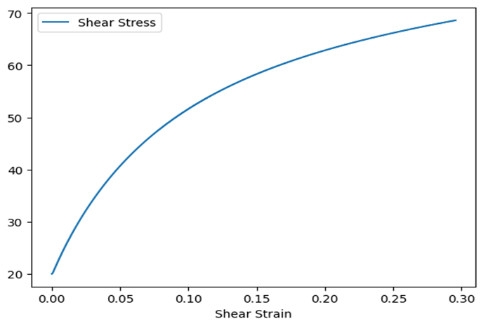

The range within which we generated values of the parameters are as follows:

θ∞  from 11.557064283718576 to 99.84729348962728

τc0 from 8.761240303245543e-05 to 89.55513609453024

τsfrom 52.432747351600 to 148.10915629466336

θ0  from 51.215570416641405 to 927.0565385810537

Then we generated τc0,τs,θ0 and θ∞  and calculated MAE for each case. Then we trained our ML model on these parameters such that for a given set of parameters it outputs the expected MAE.

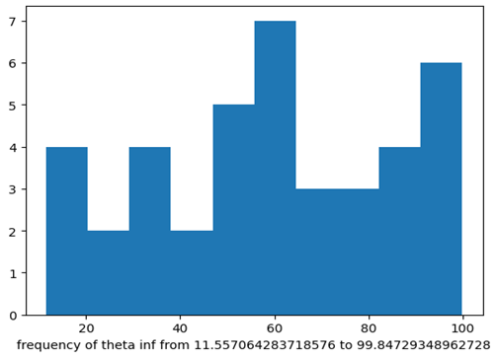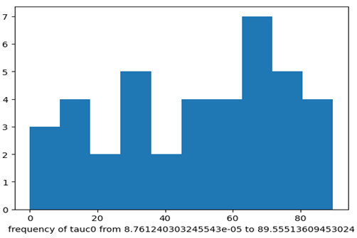

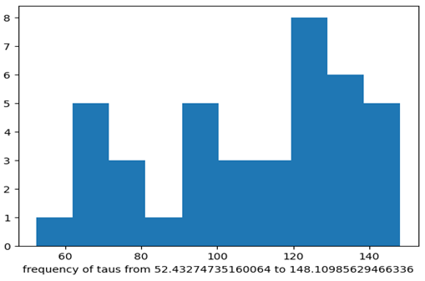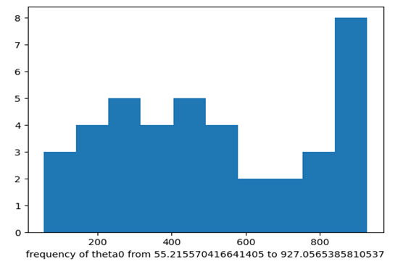

Then the set of parameters with least MAE is selected whose curve when plotted against the plotted data points is as shown:

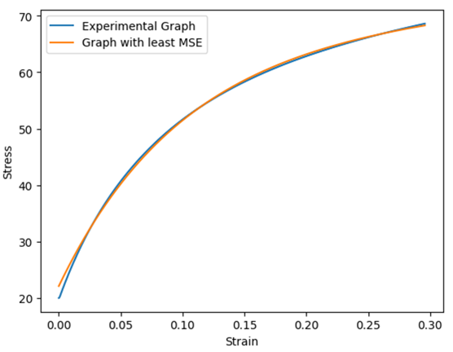

And the parameters for the given best fitting curve are as follows:

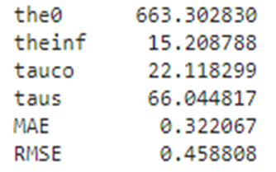

Now we split our dataset into train and test set, use standard scaler for normalization and apply different machine learning models on our train dataset.

